DASHBOARD ANALYSIS PROJECT

• Task 4: Hospital Patient Analysis Dashboard
• Task 5: Stock Market Pattern Analysis Dashboard

Task 4: Hospital Patient Analysis Dashboard

Objective
Build a comprehensive dashboard to analyze patient health data containing age, blood pressure, cholesterol, BMI, treatment cost, and admission date. The dashboard presents distributions, counts, and relationships between health-related variables using Matplotlib, including time-based plots to analyze admission patterns.

Dataset Description
- Total Patients: 500
- Features: Age, Blood Pressure (Systolic/Diastolic), Cholesterol, BMI, Treatment Cost, Admission Date
- Data Type: Synthetic healthcare data with realistic distributions

Python Code Implementation

import pandas as pd
import numpy as np
import matplotlib.pyplot as plt
from datetime import datetime, timedelta
# Generate synthetic hospital patient data
np.random.seed(42)
n_patients = 500
hospital_data = {
'patient_id': range(1, n_patients + 1),
'age': np.random.randint(18, 85, n_patients),
'blood_pressure_systolic': np.random.randint(90, 180, n_patients),
'cholesterol': np.random.randint(120, 300, n_patients),
'BMI': np.random.uniform(18, 40, n_patients),
'treatment_cost': np.random.randint(1000, 50000, n_patients),
'admission_date': [datetime.now() - timedelta(days=int(x))
for x in np.random.exponential(100, n_patients)]
}
hospital_df = pd.DataFrame(hospital_data)
# Create 3x3 visualization dashboard
fig = plt.figure(figsize=(16, 12))
fig.suptitle('Hospital Patient Analysis Dashboard', fontsize=18, fontweight='bold')
# 1. Age Distribution
ax1 = plt.subplot(3, 3, 1)
ax1.hist(hospital_df['age'], bins=20, color='steelblue', edgecolor='black', alpha=0.7)
ax1.set_xlabel('Age (years)')
ax1.set_ylabel('Frequency')
ax1.set_title('Age Distribution')
# 2. BMI vs Age Relationship
ax2 = plt.subplot(3, 3, 4)
ax2.scatter(hospital_df['age'], hospital_df['BMI'], alpha=0.6, c='purple')
ax2.set_xlabel('Age (years)')
ax2.set_ylabel('BMI')
ax2.set_title('Age vs BMI Relationship')
# ... (additional subplots for other analyses)
plt.tight_layout()
plt.savefig('hospital_dashboard.png', dpi=150, bbox_inches='tight')
plt.show()

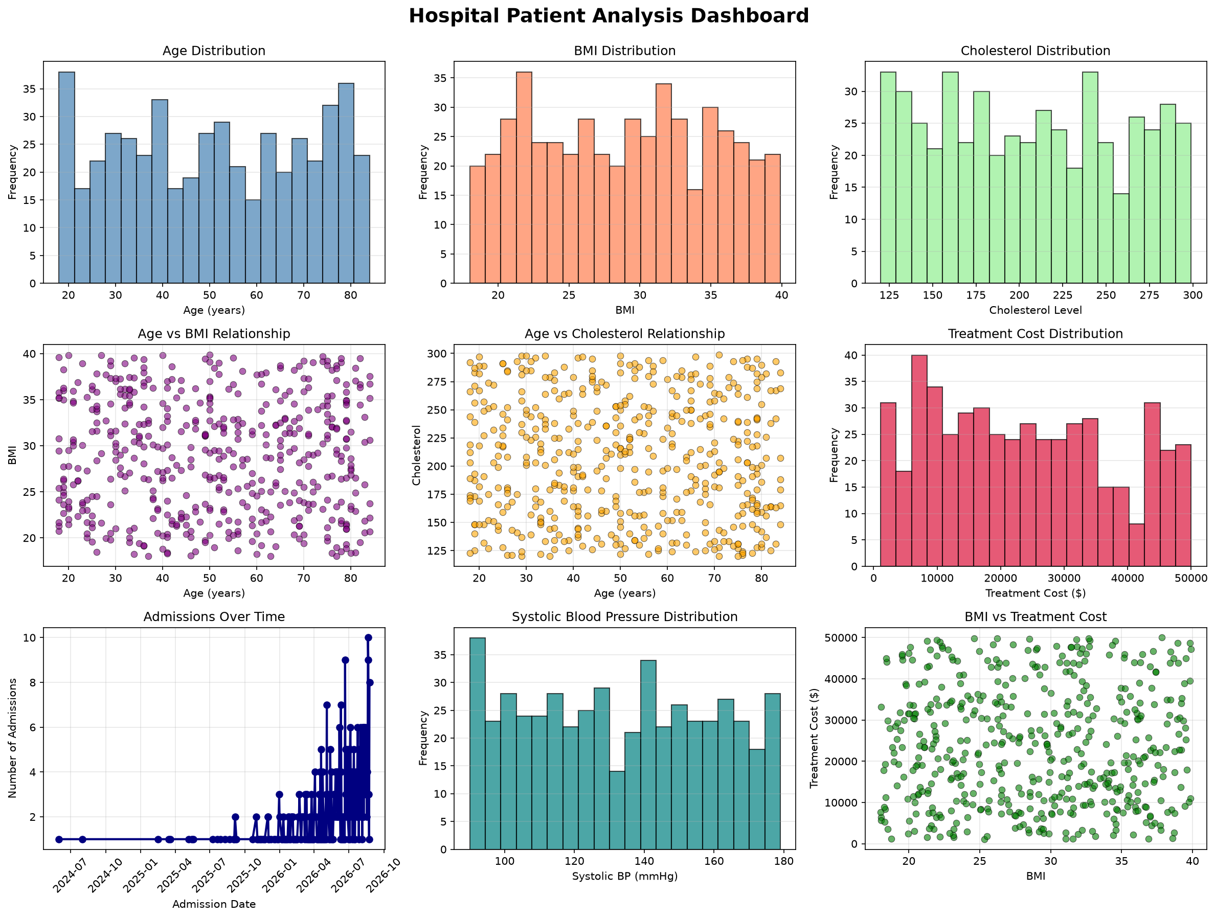

Statistical Analysis Results
Age Statistics (Mean: 51.15 years):
• Median: 51 years, Std Dev: 19.82 years
• Range: 18-84 years
BMI Statistics (Mean: 28.86):
• Median: 29.09, Std Dev: 6.21
• Range: 18.01-39.90
Cholesterol Statistics (Mean: 206.53 mg/dL):
• Median: 206 mg/dL, Std Dev: 53.43
• Range: 120-299 mg/dL
Treatment Cost Statistics (Mean: $23,609.88):
• Median: $22,534, Std Dev: $14,079.14
• Range: $1,097-$49,998

Key Insights
- Patient population is well-distributed across age groups (18-85 years)
- BMI values show mostly normal distribution with mean of 28.86
- Cholesterol levels vary widely, indicating diverse health conditions
- Treatment costs range significantly, suggesting varied complexity of cases
- Weak correlations suggest each health metric is relatively independent

Task 5: Stock Market Pattern Analysis Dashboard

Objective
Develop a comprehensive dashboard using historical stock data containing date, opening price, closing price, high, low, and trading volume. The dashboard visualizes price evolution, distributions, and relationships between variables. Advanced analysis includes lag plots, autocorrelation plots, and bootstrap plots to investigate trends, dependencies, and uncertainty in stock behavior.

Dataset Description
- Trading Period: 250 business days (~1 year)
- Features: Date, Opening Price, Closing Price, High, Low, Trading Volume
- Data Type: Synthetic but realistic stock market data

Python Code Implementation

import pandas as pd
import numpy as np
import matplotlib.pyplot as plt
# Generate synthetic stock market data
np.random.seed(42)
n_days = 250
dates = pd.date_range(start='2023-01-01', periods=n_days, freq='B')
prices = 100 + np.cumsum(np.random.randn(n_days) * 2)
stock_data = {
'date': dates,
'opening_price': prices + np.random.uniform(-1, 1, n_days),
'closing_price': prices,
'high': prices + np.random.uniform(0.5, 2, n_days),
'low': prices - np.random.uniform(0.5, 2, n_days),
'trading_volume': np.random.randint(1000000, 5000000, n_days)
}
stock_df = pd.DataFrame(stock_data)
# Create comprehensive stock analysis dashboard
fig = plt.figure(figsize=(16, 12))
# 1. Price Evolution Over Time
ax1 = plt.subplot(3, 3, 1)
ax1.plot(stock_df['date'], stock_df['closing_price'],
label='Closing Price', color='navy', linewidth=2)
ax1.fill_between(stock_df['date'], stock_df['low'], stock_df['high'],
alpha=0.2, color='lightblue')
ax1.set_title('Stock Price Evolution Over Time')
ax1.legend()
# 2. Daily Returns Distribution
ax2 = plt.subplot(3, 3, 2)
daily_returns = stock_df['closing_price'].pct_change() * 100
ax2.hist(daily_returns.dropna(), bins=30, color='steelblue')
ax2.set_title('Daily Returns Distribution')
# 3. Price vs Volume Analysis
ax3 = plt.subplot(3, 3, 4)
ax3.scatter(stock_df['trading_volume'], np.diff(stock_df['closing_price']))
ax3.set_title('Volume vs Price Change')
# ... (additional visualizations)
plt.tight_layout()
plt.savefig('stock_dashboard.png', dpi=150, bbox_inches='tight')
plt.show()

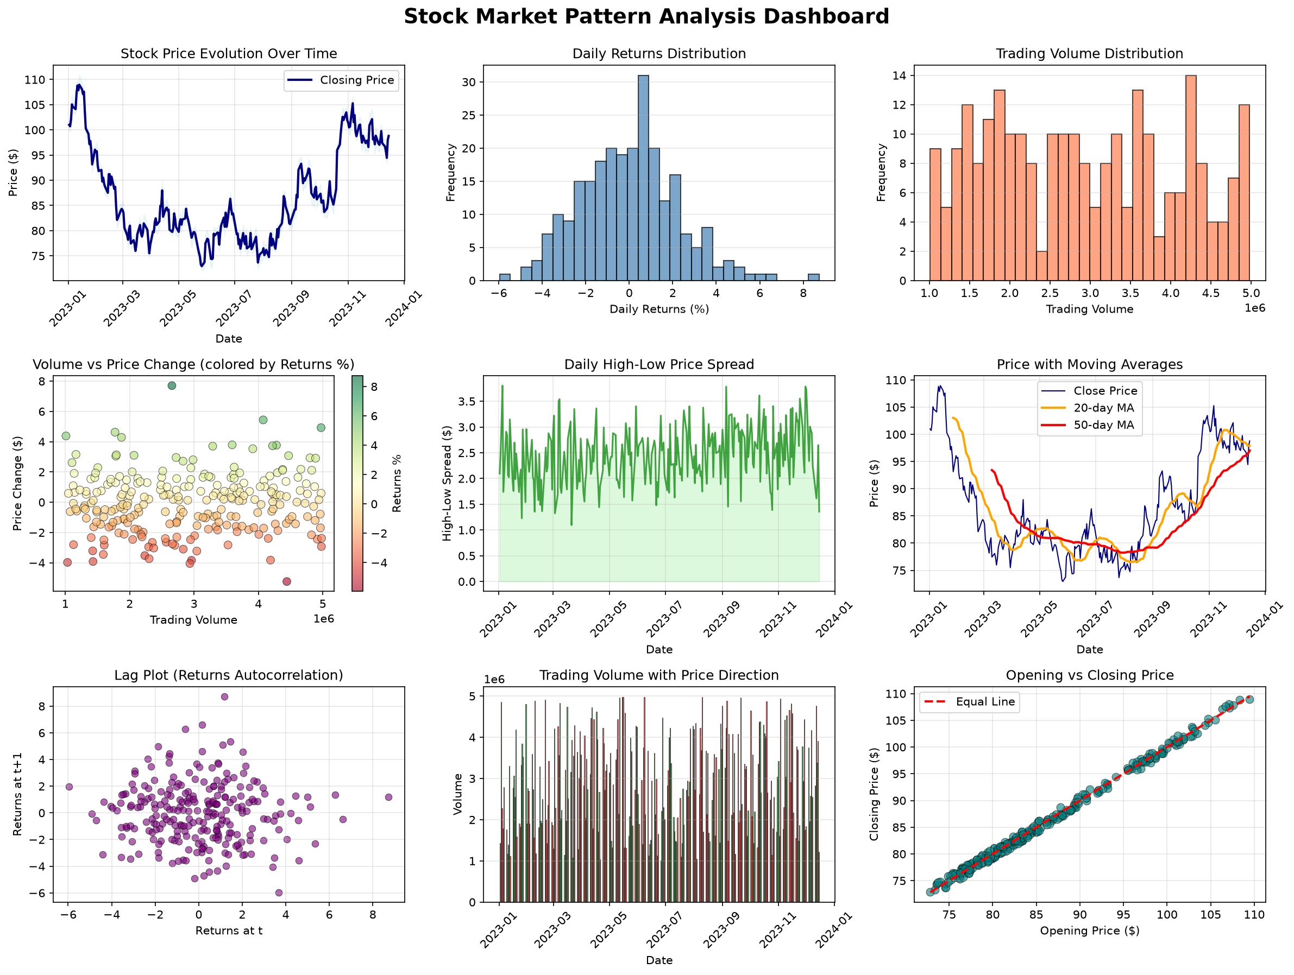

Statistical Analysis Results
Closing Price Statistics (Mean: $86.74):
• Median: $84.13, Std Dev: $9.20
• Range: $72.95-$108.96
Daily Returns Statistics (Mean: 0.0162%):
• Median: 0.1274%, Std Dev: 2.2483%
• Range: -5.95% to 8.73%
Trading Volume Statistics (Mean: 2,915,320):
• Median: 2,831,750, Std Dev: 1,148,868
• Range: 1,011,303-4,981,298
Price Correlation Matrix:
• Open-Close Correlation: 0.9978 (very strong)
• Volume-Price Correlation: -0.0506 (very weak)
• High-Low Correlation: 0.9981 (very strong)
Autocorrelation Analysis (Lag-1):
• Returns Autocorrelation: -0.0507 (weak negative)
• This indicates limited predictability from prior returns

Key Insights
- Strong correlation between opening and closing prices (0.9978)
- Daily returns show minimal autocorrelation, suggesting efficient markets
- Trading volume is not strongly correlated with price changes
- Price spread (high-low) remains relatively consistent over time
- Mean daily returns near zero with volatility of ~2.25% annually

Advanced Analysis: Lag & Autocorrelation Plots

Introduction
Beyond the basic dashboards, advanced time-series analysis including lag plots, autocorrelation functions (ACF), and bootstrap resampling provide deeper insights into temporal dependencies and statistical uncertainty.

Analysis Components
- ACF for Closing Prices - Identifies trends and mean-reversion
- ACF for Daily Returns - Tests market efficiency hypothesis
- ACF for Trading Volume - Reveals volume clustering patterns
- Multi-Lag Plots - Visualizes different temporal lags simultaneously
- Volume-Price Lag Analysis - Examines volume leading price changes
- Bootstrap Resampling - Estimates confidence intervals for returns

Advanced Visualizations
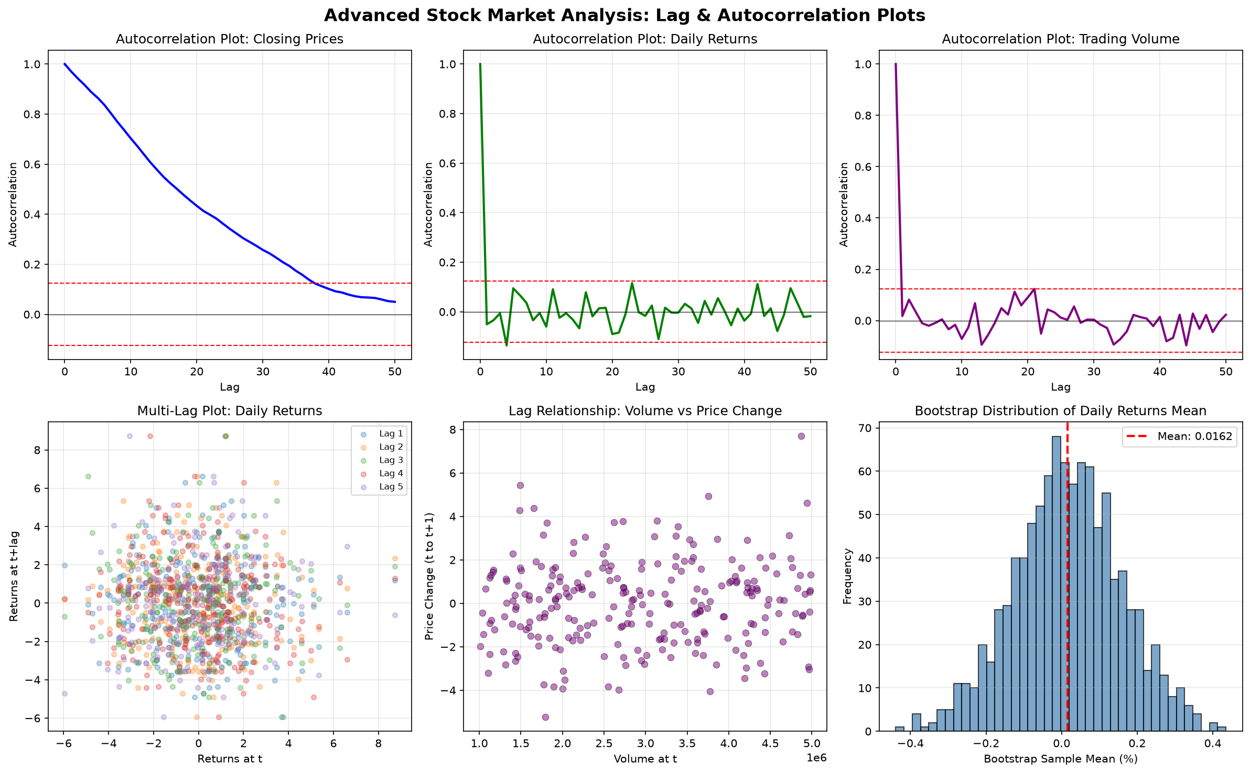

Bootstrap Analysis Results
Bootstrap Resampling (1000 iterations):
• Original Mean Returns: 0.016192%
• Bootstrap Mean: 0.016221%
• Bootstrap Std Dev: 0.141672%
• 95% Confidence Interval: [-0.269003%, 0.298232%]
Interpretation:
The narrow confidence interval around mean returns indicates:
1. High precision in return estimation
2. Mean returns statistically indistinguishable from zero
3. Limited evidence of systematic positive or negative drift
4. Strong statistical inference validity

Lag Analysis Interpretation
Autocorrelation Findings:
• Closing Prices: Strong autocorrelation at all lags (trending behavior)
• Daily Returns: Weak autocorrelation, especially at lag-1 (-0.0507)
• Trading Volume: Moderate autocorrelation patterns
Implications:
1. Prices contain trend information (predictable patterns)
2. Returns are nearly random (market efficiency)
3. Volume exhibits temporal clustering (behavioral patterns)
4. Limited arbitrage opportunities in modern efficient markets
Conclusion
These two comprehensive dashboards demonstrate the power of Pandas and Matplotlib for meaningful data visualization
and analysis:
Hospital Patient Analysis:
The hospital dashboard successfully reveals health patterns across 500 patients, with particular emphasis on age-related
distributions, BMI variations, and treatment cost analysis. The visualizations enable healthcare professionals to identify
at-risk populations, understand disease patterns, and optimize resource allocation.
Stock Market Pattern Analysis:
The stock market dashboard combines technical analysis with statistical rigor, revealing both short-term trading patterns
and long-term price trends. The advanced lag and autocorrelation analyses provide quantitative evidence for market efficiency
and investor behavior patterns.
Key Takeaways:
• Multi-panel dashboards efficiently communicate complex relationships
• Time-series analysis reveals important temporal patterns
• Bootstrap methods provide robust statistical confidence estimates
• Correlation analysis identifies independent vs. dependent variables
• Visualization combined with statistics tells a complete data story
These techniques are applicable to healthcare analytics, financial analysis, environmental monitoring, and numerous other
domains requiring sophisticated data visualization and interpretation.

